**Project Title:-** Smart Assignment Engine

**Category:-** Cloud Application Development

**Technology Stack:-** Flask Integration, HTML,CSS, Bootstrap, Docker, Kubernetes, IBM D2B

**INTRODUCTION**

* 1. **Overview**

Smart Assignment is a web-based application designed to streamline the process of assignment management and enhance collaboration among students, teachers, and administrators. This project aims to leverage web development technologies to create an intelligent platform that automates assignment creation, submission, grading, and feedback, thereby improving the efficiency and effectiveness of the assignment process. Students can access the platform to view and submit assignments. The application allows for secure file uploads, ensuring the integrity and confidentiality of submitted work. The system provides notifications and reminders to students about upcoming assignment due dates and any updates or clarifications from teachers.

Smart Assignment aims to enhance the assignment management process, promote collaboration, and improve educational outcomes. By leveraging intelligent technologies and providing a user-friendly interface, the application streamlines administrative tasks, enhances student-teacher communication, and facilitates a more efficient and engaging learning experience.

* 1. **Purpose**

The Smart Assignment project serves various stakeholders within the educational ecosystem, and its use extends to different user groups:

Students:

Assignment Submission: Students can use Smart Assignment to submit their assignments online. This is convenient as it eliminates the need for physical submissions and ensures that their work is securely uploaded.

Access to Assignment Details: Students can view assignment details, including due dates, instructions, and grading criteria, which helps them stay organized and informed about their coursework.

Notifications: The platform sends students notifications and reminders about upcoming assignment due dates and any updates or clarifications from their teachers, helping them manage their time effectively.

Teachers:

Assignment Creation: Teachers can create assignments through the platform, specifying the necessary details and criteria. This simplifies the assignment creation process and ensures that all relevant information is available to students.

Automated Grading: For assignments amenable to automated evaluation, teachers can use Smart Assignment to automate the grading process, saving time and reducing the risk of errors.

Feedback: Teachers can provide timely and constructive feedback to students through the platform, facilitating continuous improvement in student performance.

Communication: The platform enables teachers to communicate with students, making it easier to address questions, provide guidance, and share updates related to assignments.

Administrators:

Administrative Efficiency: Administrators benefit from the platform's ability to streamline administrative tasks related to assignment management, reducing paperwork and administrative burdens.

Overall, the use of the Smart Assignment project is to streamline and improve the entire assignment management process within educational institutions. It promotes collaboration, communication, and efficiency among students, teachers, and administrators, ultimately aiming to enhance the educational experience and improve learning outcomes.

1. **LITERATURE SURVEY**
   1. Existing problemThe business problem that Smart Assignment aims to address is the inefficiency and complexity of traditional assignment management processes within educational institutions. Traditional assignment management often involves manual tasks, disjointed communication, and potential delays in feedback, which can lead to various challenges for students, teachers, and administrators. These challenges include:

* Time-Consuming Processes: Creating, distributing, collecting, and grading assignments can be time-consuming for teachers and administrators, taking away valuable time that could be spent on more impactful tasks.
* Lack of Timely Feedback: Students often have to wait for extended periods to receive feedback on their assignments, which can hinder their learning progress and ability to make improvements.
* Communication Gaps: Miscommunication and lack of clarity in assignment instructions or updates can result in confusion among students. Teachers might find it difficult to convey important information to all students effectively.
* Deadline Management: Students might struggle to keep track of multiple assignment deadlines, leading to last-minute rushes and subpar work quality.
* Data Security Concerns: Sharing assignments through physical means or unsecured platforms can raise concerns about data security and privacy.
* Variability in Grading: Manual grading can introduce inconsistencies in evaluation, impacting the fairness and accuracy of grading.

Smart Assignment aims to solve these problems by providing a centralized, automated, and user-friendly platform that streamlines assignment management processes. The platform's automation, communication features, and timely feedback mechanisms can lead to improved efficiency, enhanced collaboration, and better educational outcomes for all stakeholders involved.

* 1. Proposed solution

Proposed Smart Assignment project will solve above mentioned issues by providing following features and functionalities.

* Centralized Assignment Repository: The platform should provide a centralized location where both students and teachers can access and manage assignments.
* Automated Assignment Creation: The system should allow teachers to easily create assignments, specifying details such as title, description, due date, and any associated materials.
* Secure Assignment Submission: Students should be able to securely upload their assignment files to the platform, ensuring data confidentiality and integrity.
* Real-time Notifications and Reminders: The system should send automatic notifications and reminders to students regarding upcoming assignment due dates, new assignments, and any updates from teachers.
* Online Grading and Feedback: Teachers should be able to grade assignments online, providing detailed feedback to students. The platform should support different grading methods (e.g., points, rubrics).
* Instant Feedback Delivery: Once assignments are graded, the system should promptly notify students and provide them with access to their graded assignments and feedback.
* Communication Platform: The platform should facilitate communication among students, teachers, and administrators, allowing for questions, clarifications, and updates related to assignments.
* User-friendly Interface: The user interface should be intuitive and easy to navigate for all user roles, promoting user adoption and engagement.
* Cross-Device Compatibility: The platform should be accessible across various devices (computers, tablets, smartphones) to accommodate different user preferences.
* Data Security and Privacy: The system should ensure that uploaded assignment files and personal information remain secure and comply with relevant data protection regulations.
* Customizable Assignment Templates: Teachers should have the option to create assignment templates that can be reused, saving time in assignment setup.
* Scalability and Performance: The platform should be designed to handle a growing number of users and assignments without compromising performance or user experience.

1. **THEORITICAL ANALYSIS**

3.1 Block diagram

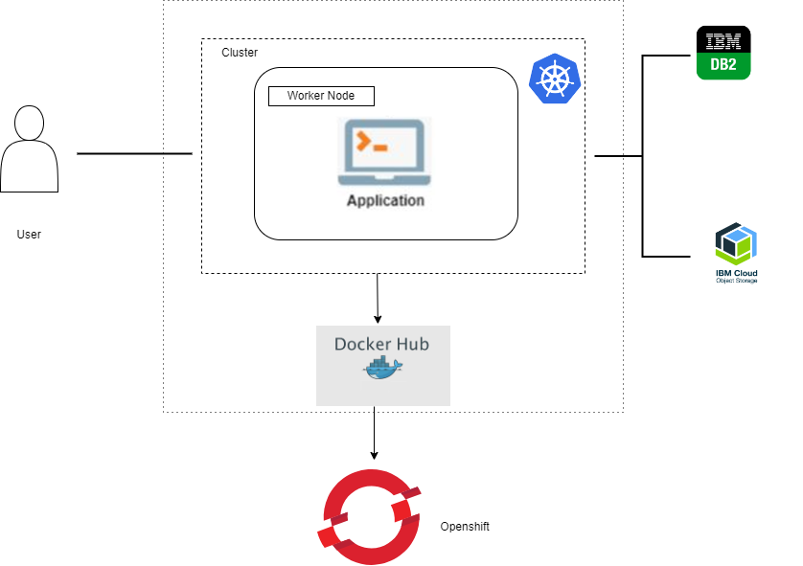

3.2 Hardware / Software designing

Flask Integration, HTML,CSS, Bootstrap, Docker, Kubernetes, IBM D2B

1. **EXPERIMENTAL INVESTIGATIONS**

During the development of the Smart Assignment project, various analyses and investigations would have been conducted to ensure that the solution meets its intended goals and functions effectively. Here are some key areas where analysis and investigation would be crucial:

* Understanding the specific needs and pain points of students, teachers, and administrators in the assignment management process.
* Conducting surveys, interviews, or focus groups to gather user feedback and requirements.
* Analyzing existing assignment management processes to identify areas for improvement.Technology
* Evaluating different web development technologies, frameworks, and databases to determine the most suitable technology
* Assessing the scalability, security, and performance implications of the chosen technologies.
* Conducting a thorough security assessment to ensure that user data, including assignments and grades, is stored and transmitted securely.
* Investigating data privacy regulations and compliance requirements to ensure that the system adheres to relevant laws and standards.

**5 FLOWCHART**

**Creating a User Interface**

**Database Connection**

**Creating necessary Schemas and Tables**

**Create a Cloud Object Storage to store multimedia data.**

**Flask Application**

**Creating python’s flask web framework to connect the front end with the back end services.**

**GitHub**

**Pushing all the files to github by using git commands**

**Containerization**

**Containerize your application as a docker image and push it into Docker Desktop**

**Push the image to Docker Hub.**

**Deployment Application in Openshift**

**Deploying with Git Repository**

**Deploying with Docker Image**

**RESULT**



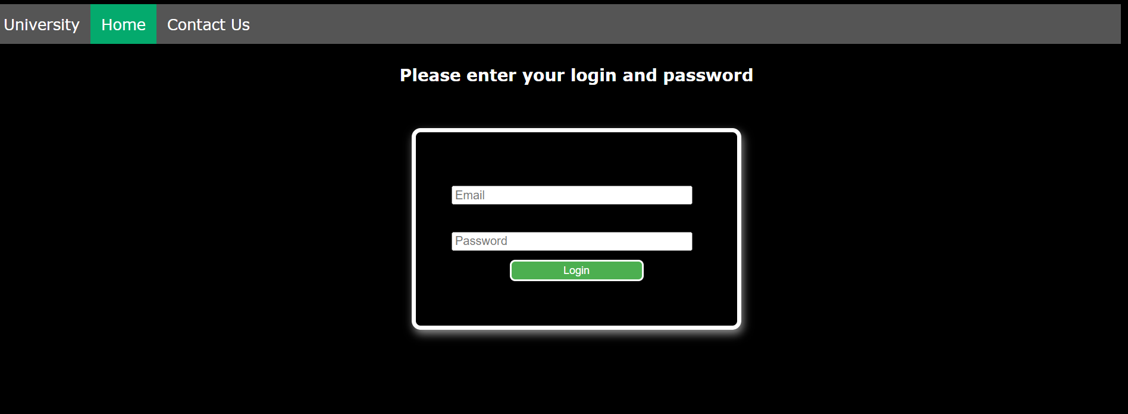

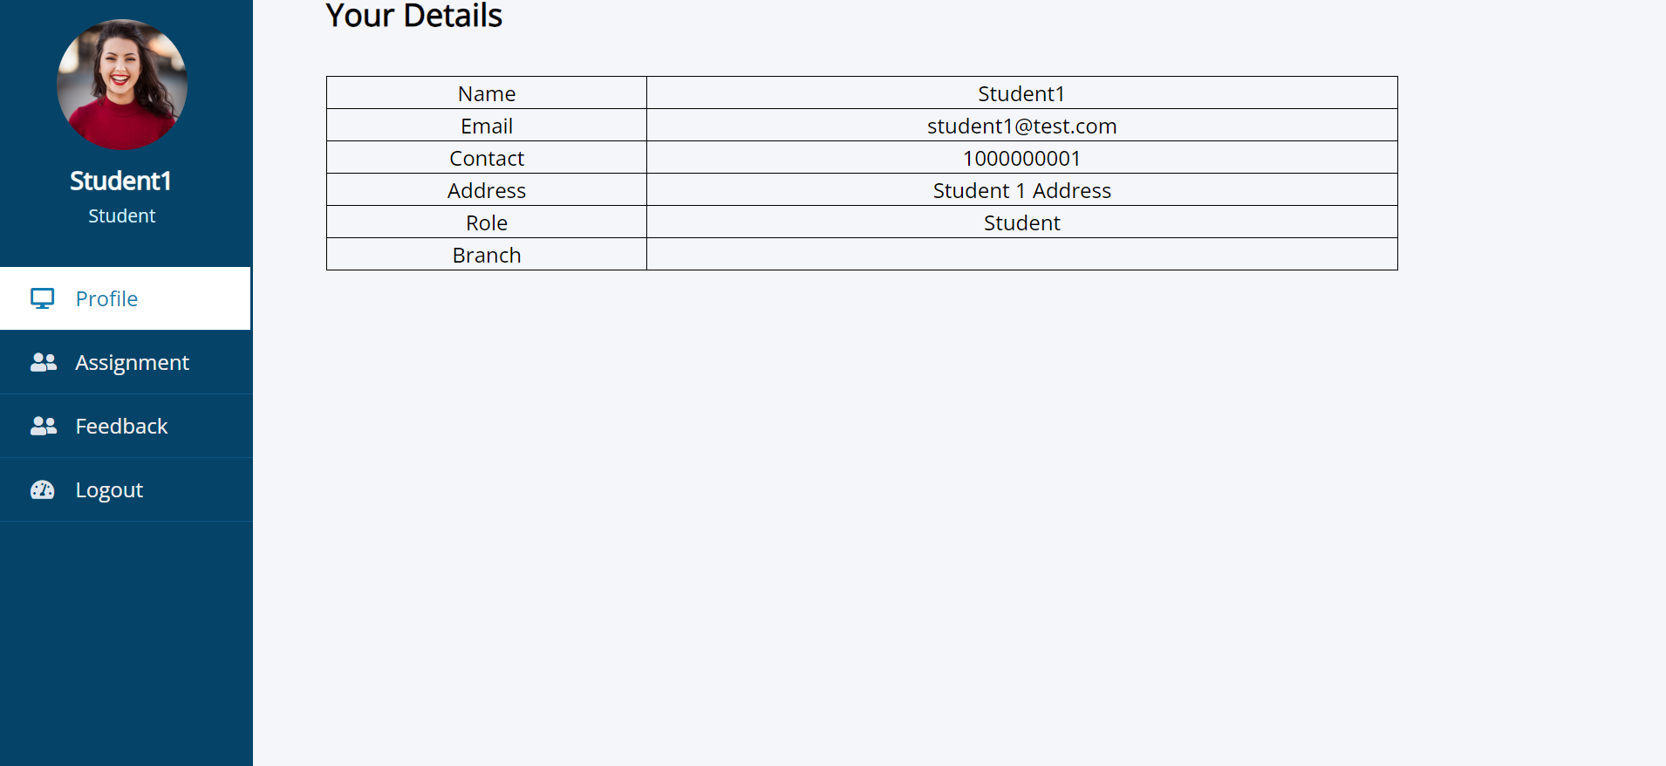

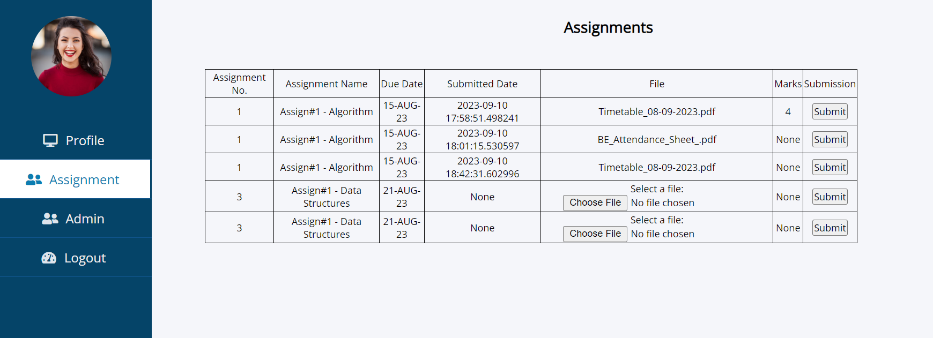

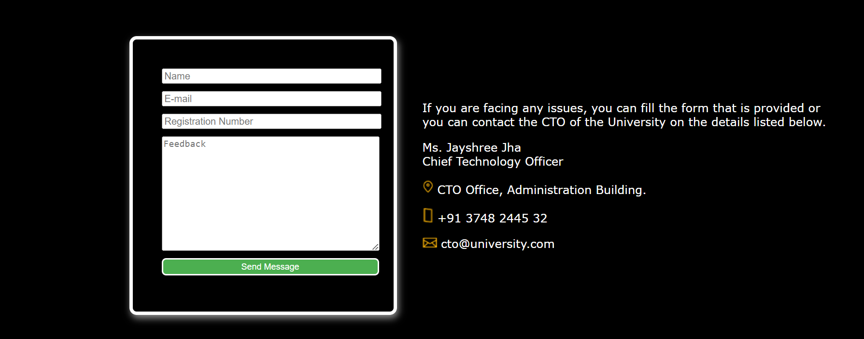

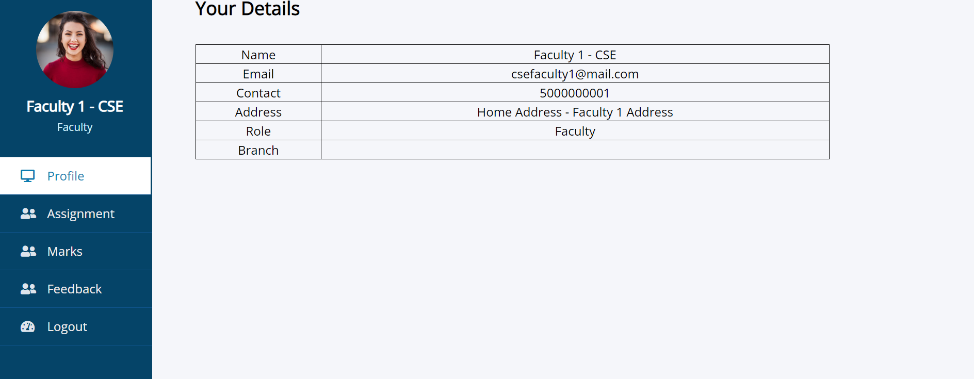



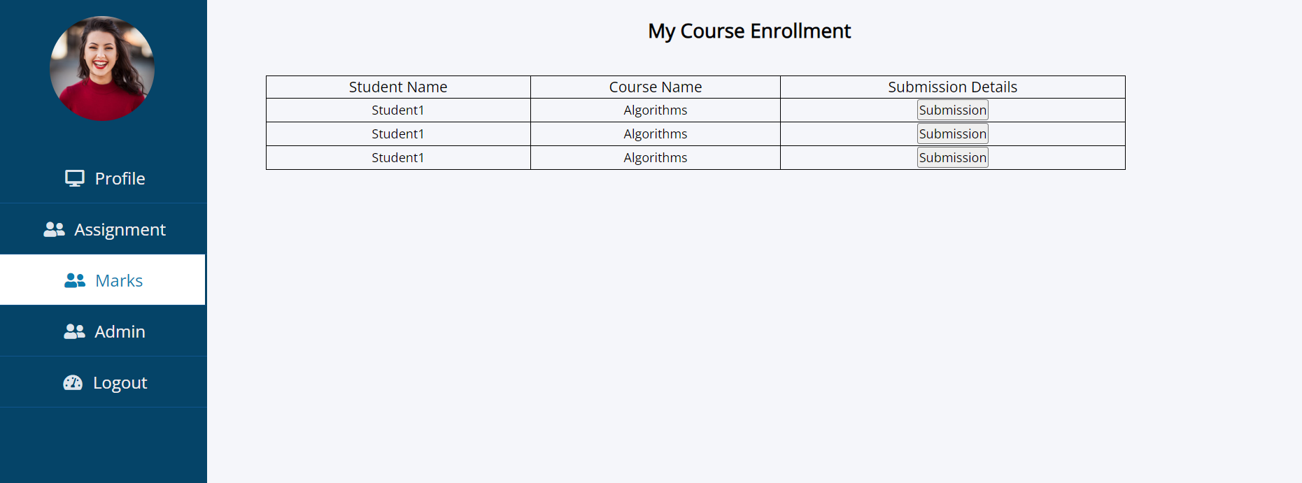

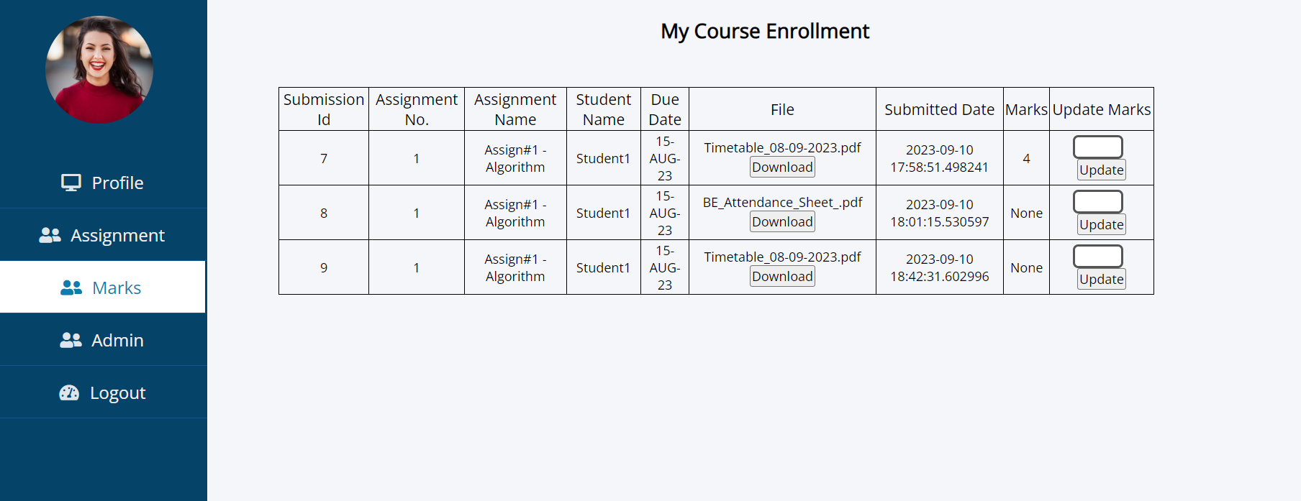



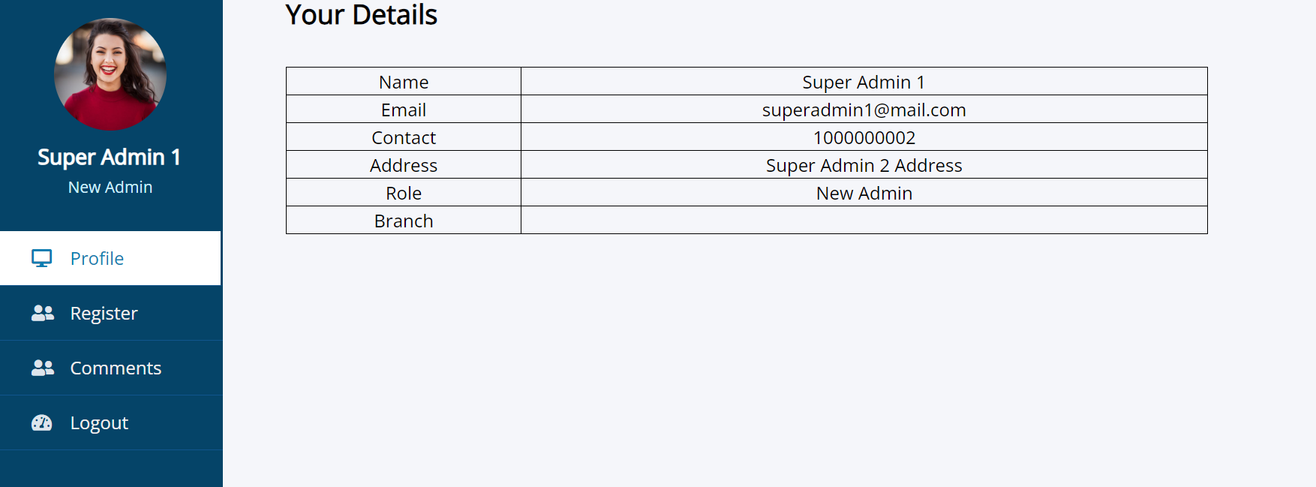

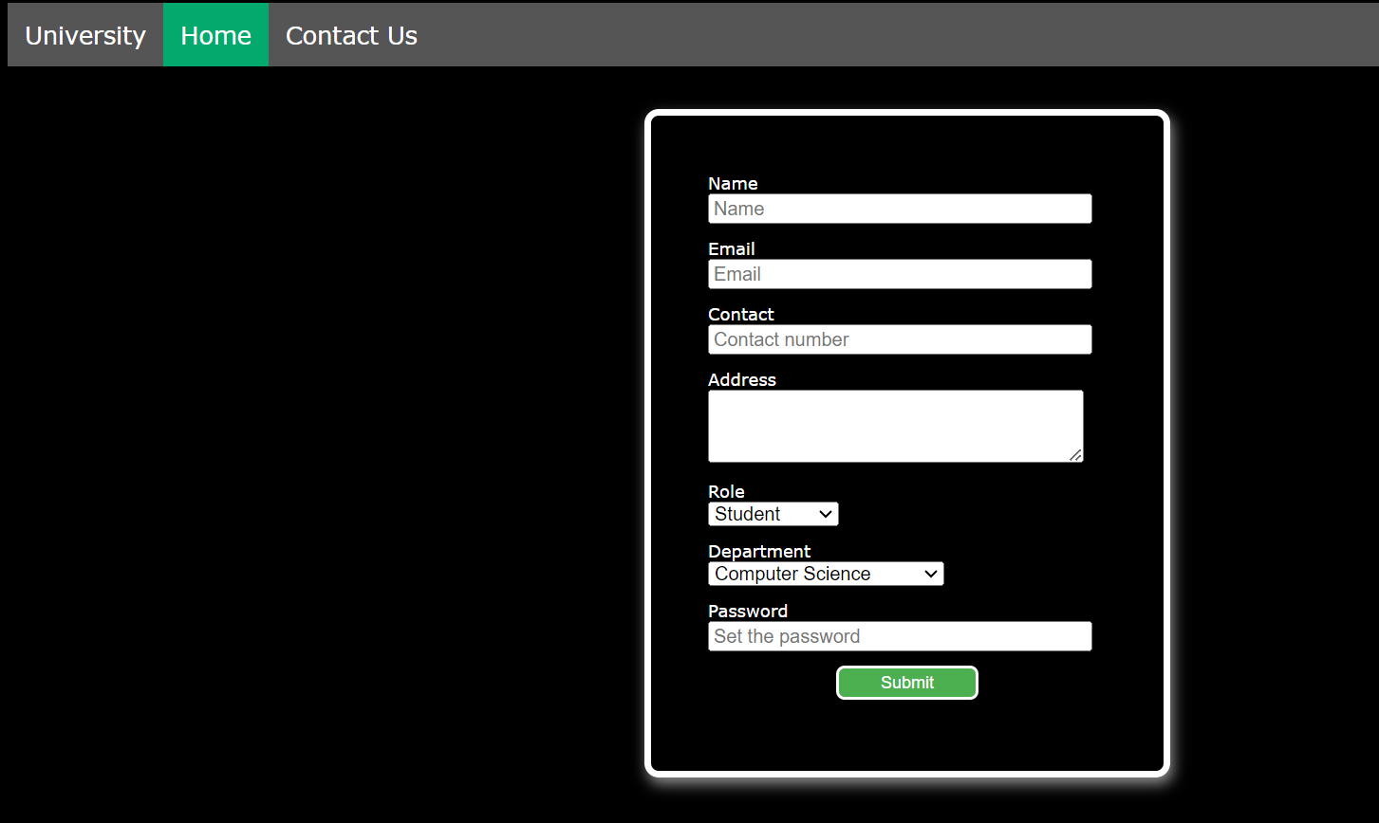

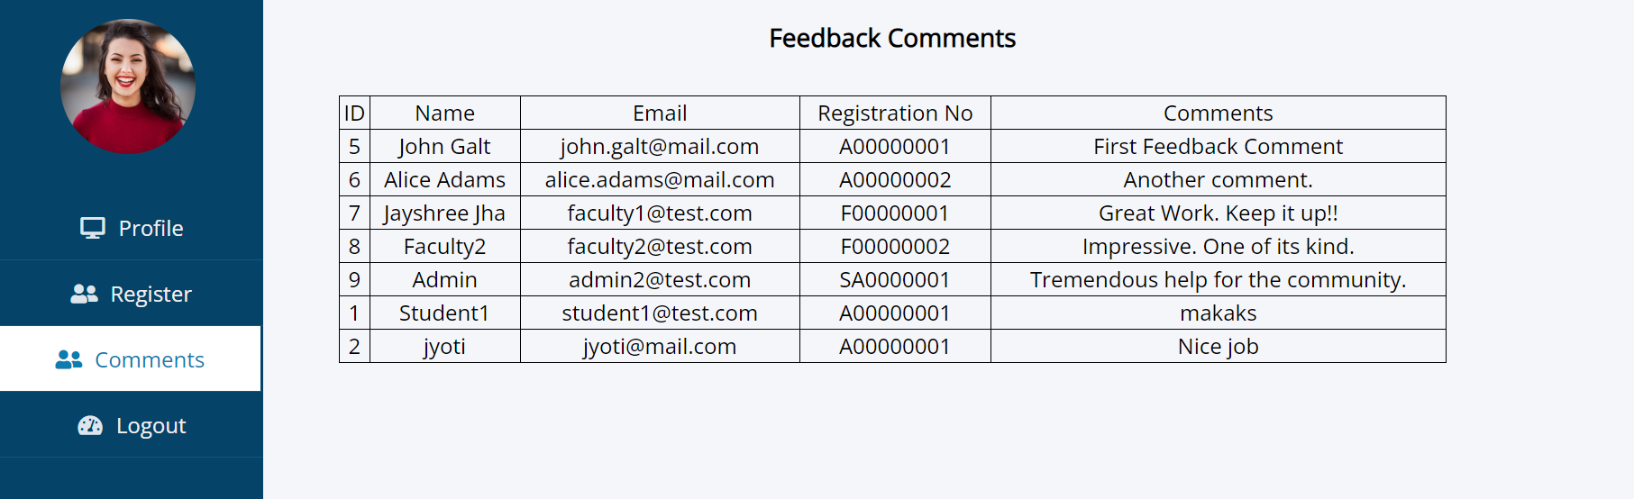

**ADVANTAGES & DISADVANTAGES**

Advantages of Smart Assignment:

* Efficiency:Streamlines the assignment management process, making it more efficient for both teachers and students. Automation reduces administrative workload.
* Improved Communication: Facilitates better communication between students and teachers through notifications and updates, leading to increased engagement.
* Enhanced Learning Experience:Provides a user-friendly interface and timely feedback, contributing to a more engaging and productive learning experience.
* Data Insights:Generates data insights that can help educators identify areas for improvement and tailor their teaching methods accordingly.
* Security: Ensures the security and confidentiality of submitted assignments through secure file uploads.
* Accessibility: Can be designed to meet accessibility standards, making it inclusive for users with disabilities.
* Customization: Offers the potential for customization, allowing educational institutions to adapt the platform to their specific needs.

**Disadvantages and Challenges of Smart Assignment:**

* Implementation Costs: Developing and deploying the Smart Assignment platform can involve significant upfront costs in terms of development, infrastructure, and training.
* User Adoption: Users, especially older educators or students less familiar with technology, may face a learning curve when adopting the platform.
* Technical Issues: Like all technology solutions, Smart Assignment may experience technical glitches, downtime, or compatibility.
* Data Privacy Concerns: Storing student data online raises concerns about data privacy and security. Institutions must take appropriate measures to protect sensitive information.
* Overreliance on Technology: There's a risk that students and teachers may become overly reliant on the platform, reducing face-to-face interactions and personal communication.
* Costs: Implementing and maintaining such a system can incur costs, including software development, infrastructure, and ongoing support.
* User Resistance: Some students and teachers may resist using technology for assignment management, preferring traditional methods.

**APPLICATIONS**

Here are some key applications of Smart Assignment:

* K-12 Schools: Smart Assignment can be used in K-12 schools to manage assignments for students across different grade levels and subjects.It can assist teachers in creating and grading assignments, providing feedback to students, and tracking their progress.
* Higher Education Institutions: Colleges and universities can use Smart Assignment to handle assignments for a wide range of courses and disciplines.It can be particularly useful in large lecture-style classes with many students, where automation and efficient communication are essential.
* Online Learning Platforms: Smart Assignment can be integrated into online learning platforms and Learning Management Systems (LMS) to streamline assignment management for virtual classrooms. It complements other e-learning tools by providing a centralized system for assignment creation, submission, and grading.
* Professional Training Programs: Organizations offering professional development or training programs can utilize Smart Assignment to manage assignments and assessments for their participants. It helps trainers automate grading and provide timely feedback.
* Specialized Training Centres: Institutions providing specialized training, such as vocational schools or technical institutes, can employ Smart Assignment to manage assignments related to hands-on training and coursework.
* Language Learning Institutions: Language schools and institutions can use Smart Assignment to assign language exercises, essays, and other language-related tasks, streamlining the grading and feedback process.
* Continuous Education Programs: Programs offering lifelong learning and continuous education for adults and professionals can benefit from Smart Assignment's features for managing assignments and assessments.
* Teacher Professional Development: Educational organizations can utilize the platform for teacher training and professional

**CONCLUSION**

Smart Assignment is a versatile web-based application designed to revolutionize assignment management and foster collaboration within educational institutions and corporate training programs. This intelligent platform leverages web development technologies to automate assignment creation, submission, grading, and feedback processes, offering numerous advantages such as increased efficiency, enhanced communication, and valuable data insights. While Smart Assignment brings significant benefits, it is essential to consider its potential disadvantages, including the initial setup, technical issues, data privacy concerns, and the risk of overreliance on technology. Successful implementation and integration of Smart Assignment require careful planning, training, and ongoing evaluation to ensure alignment with the goals and values of the educational institution or organization.

Overall, Smart Assignment has the potential to transform the educational landscape by providing a user-friendly, efficient, and collaborative environment for students, teachers, and administrators. As technology continues to advance, solutions like Smart Assignment will play a pivotal role in improving learning outcomes and enhancing the educational experience for all stakeholders.

**FUTURE SCOPE**

* The future scope of Smart Assignment and similar educational technology solutions is promising, as technology continues to play an increasingly significant role in education. Here are some potential areas of future development and expansion for Smart Assignment:
* Artificial Intelligence (AI) Integration: Future iterations of Smart Assignment can incorporate more advanced AI capabilities, such as natural language processing for grading written assignments, personalized learning recommendations, and intelligent tutoring systems that provide real-time assistance to students.
* Adaptive Learning: Smart Assignment could evolve to become an adaptive learning platform, where assignments and content are dynamically adjusted based on each student's performance and learning pace, allowing for truly personalized learning experiences.
* Blockchain for Credential Verification: Integrating blockchain technology into Smart Assignment could enhance the security and authenticity of academic credentials, making it easier for students to share their achievements with potential employers or educational institutions.
* Virtual and Augmented Reality (VR/AR) Integration: Future versions of Smart Assignment could leverage VR/AR technology to create immersive learning experiences, allowing students to interact with assignments in three-dimensional virtual environments.
* Global Collaboration: Expanding the platform to support global collaboration among students and educators from different parts of the world can enhance cross-cultural learning experiences and prepare students for a globalized workforce.
* Mobile Accessibility: Ensuring that Smart Assignment is fully accessible on mobile devices can improve convenience and accessibility for users, especially in regions with high mobile device adoption.
* Enhanced Data Analytics: Continuously improving data analytics and machine learning algorithms can provide more profound insights into student performance, allowing educators to make data-driven decisions and interventions.
* Integration with Learning Management Systems (LMS): Seamless integration with popular LMS platforms can make Smart Assignment a core component of the educational technology stack, simplifying adoption for educational institutions.
* Gamification Elements: Incorporating gamification elements into assignments can boost student engagement and motivation, making learning more enjoyable and effective.
* Accessibility and Inclusivity: Ensuring that the platform adheres to the highest accessibility standards and is inclusive for all students, including those with disabilities, is an essential aspect of future development.
* Security and Privacy Enhancements: Ongoing efforts to strengthen data security and privacy measures will be crucial to maintain user trust and compliance with evolving data protection regulations.
* Customization and Branding: Providing customization options and branding capabilities for educational institutions can make Smart Assignment a more tailored and recognizable part of their educational ecosystem.
* Scalability: As the user base grows, ensuring that the platform remains scalable and can handle increasing volumes of assignments, users, and data will be a priority.
* The future of Smart Assignment lies in its ability to adapt to emerging technologies and educational trends while addressing the evolving needs of students, teachers, and administrators. As technology continues to evolve, Smart Assignment and similar platforms will play a pivotal role in shaping the future of education by promoting efficiency, collaboration, and personalized learning experiences.